Software Development Process Framework
(CMMI-Aligned)
Ver 1.0
Introduction
This document defines the end-to-end software development process adopted in alignment with CMMI practices. It provides a standardized, repeatable, and measurable approach to planning, designing, developing, releasing, and maintaining software products. The process ensures that all activities are performed consistently across projects, roles and responsibilities are clearly defined, and artefacts are produced in a controlled and auditable manner. It also supports continuous improvement by establishing traceability, accountability, and visibility throughout the application lifecycle.
Purpose
The purpose of this document is to establish a comprehensive development lifecycle model that integrates CMMI best practices with Agile/Scrum delivery. It outlines what needs to be done, when it should be done, who is responsible for specific actions, and which deliverables must be produced before progressing to the next phase. This ensures that the development organization maintains quality, operational efficiency, predictable delivery, and compliance with internal governance frameworks.
Objective
The objectives of this process document are to:
- Provide a unified and repeatable process framework for development teams.
- Define clear entry criteria, inputs, triggers, and deliverables for each process phase.
- Establish role-based responsibilities using RACI matrices.
- Enhance collaboration among Solution Architecture, Business Analysts, Developers, QA, Release Management, and Project/Delivery Management.
- Ensure disciplined execution of development work consistent with CMMI maturity practices.
- Promote continuous improvement through structured feedback loops and defined quality checkpoints.
Phases of Development Process
- Planning
- Development Operation
- Release
- Bugs Fixing
Planning Phase
Overview
The Planning Phase initiates the development lifecycle and establishes the foundational direction of the project. During this phase, the Solution Architecture Lead, Business Analyst, and Technical Team collaboratively define the scope, review requirements, establish the solution approach, and develop the initial development schedule. Key architectural and design considerations are clarified to ensure alignment with business objectives and technical feasibility. This phase ensures that all stakeholders have a shared understanding of the product vision, constraints, risks, and priorities, thereby enabling effective sprint planning and backlog readiness.
Roles:
Solution Architect Lead, Solution Architect, Business Analyst (Product Owner), Tech Lead, Developers
Entry Criteria & Trigger Events:
Project Manager Sends email to Solution Architecture Lead
Input:
- Business Requirement Document
- User Stories Document
- UI/UX Specifications
Process Map
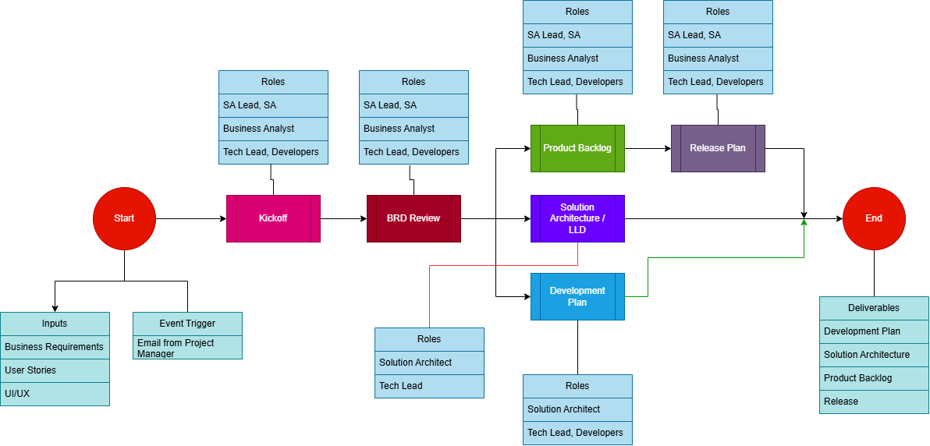
Process Actions:
Action | Responsible  Role | Accountable  Role | Consulted  Role | Informed  Role
Kick-off Meeting | Solution Architecture Lead | Solution Architecture Lead | Business Analyst  (Product Owner) | Solution Architect  Technical Lead  Developers
Review Business Requirements | Solution Architecture Lead | Solution Architecture Lead | Business Analyst (Product Owner) | Solution Architect  Technical Lead  Developers
Product Backlog / Sprint Backlog | Business Analyst  Technical Lead  Developers | Business Analyst  (Product Owner) | Scrum Master | Solution Architect
Release Plan | Tech Lead | Tech Lead | Business Analyst (Product Owner) | SCRUM Master
Prepare Development Schedule | Solution Architecture Lead | Solution Architecture Lead | Solution Architect  Technical Lead  Developers | Scrum Master
Prepare Solution Architecture & Low-Level Design | Solution Architect | Solution Architect | Business Analyst (Product Owner) | Tech Lead  Developers
Planning Phase Deliverables:
Artefact | Responsible Role | Delivery Duration
Development Plan | Solution Architecture Lead | 1 Week from Kick off
Solution Architecture | Solution Architect | 1-2 Weeks from Kick off
Product Backlog | Product Owner | 1-2 Weeks from Kick off
Sprint Backlog | Product Owner | With Product Backlog
Release Plan | Product Owner | 1 Week from Kick off
Development Operations Phase
Overview
The Development Operation Phase represents the execution cycle where development teams iteratively build the product using Scrum practices. This includes sprint planning, coding, daily stand-ups, sprint reviews, and retrospectives. Developers implement user stories, architects guide technical conformity, and the Scrum Master facilitates smooth delivery. This phase transforms planned backlog items into potentially shippable increments, ensuring adherence to technical standards, architectural guidelines, and acceptance criteria. Continuous inspection and adaptation ensure quality, predictability, and responsiveness to change.
Process Map
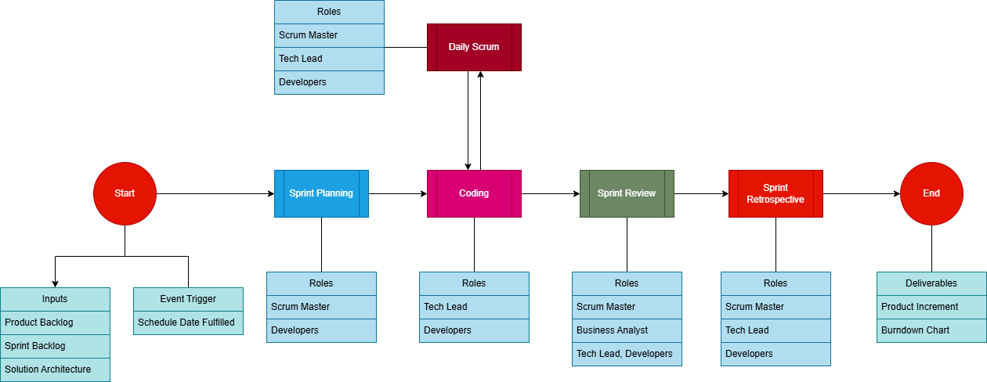

Entry Criteria & Trigger Events:
Scheduled start date fulfilled.
Input:
- Product Backlog
- Sprint Backlog
- Solution Architecture
Process Actions:
Action | Responsible  Role | Accountable  Role | Consulted  Role | Informed  Role
Sprint Planning | Scrum Master  Developers | Scrum Master  Developers | Business Analyst  (Product Owner) | Solution Architect  Tech Lead
Coding | Developers | Tech Lead | Business Analyst (Product Owner)  Solution Architect
Daily Scrum  (Stand-ups) | Tech Lead  Developers | Scrum Master |  | Business Analyst (Product Owner)
Sprint Review | Scrum Master  Tech Lead  Developers | Scrum Master  Tech Lead  Developers | Business Analyst (Product Owner) | Solution Architect
Sprint Retrospective | Scrum Master | Scrum Master | Developers  Tech Lead | Business Analyst (Product Owner)
Development Phase Deliverables:
Artefact | Roles Responsible | Delivery Duration
Burndown Chart | SCRUM Master | End of Sprint
Product Increment | Developers | End of Sprint
Release Phase
Overview
The Release Phase focuses on preparing and delivering a validated product increment to the production environment or designated release destination. Release notes document is prepared by Tech Lead describing the features included in the Release, This phase ensures that binaries are packaged correctly, dependencies are validated, and release approvals are obtained. Coordination between the Technical Lead, Release Manager, and Product Owner ensures that the product increment is ready for deployment and aligns with the agreed release schedule. The Release Phase formalizes the handover of work products and supports operational readiness.
Entry Criteria & Trigger Events:
Release schedule fulfilled
Input:
- Product Increment
- Release Plan
Process Map
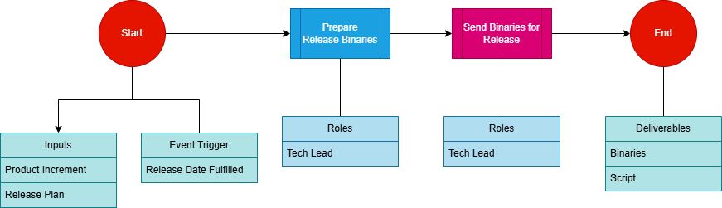
Process Actions:
Action | Responsible  Role | Accountable  Role | Consulted  Role | Informed  Role
Prepare Release notes | Tech Lead | Tech Lead | Developers | Business Analyst  (Product Owner)
Prepare binaries for Release | Tech Lead | Tech Lead |  | Developers  Business Analyst  (Product Owner)
Send Product Increment for Release | Tech Lead | Tech Lead | Release Manager | Business Analyst  (Product Owner)
Release Phase Deliverables:
Artefact | Roles Responsible | Delivery Duration
Release Binaries | Tech Lead | Release Schedule
Release Notes | Tech Lead | Release Schedule
Bug Fixing Process:
Overview
The Bug Fixing Phase is triggered when QA identifies defects during testing. The team evaluates, prioritizes, and updates the product backlog with the list of defects to be resolved. All approved bug fixes are scheduled for implementation in the next sprint, following standard sprint planning and prioritization practices. The corrected items are then delivered as part of the subsequent product increment and released in alignment with the next scheduled release cycle defined in the Release Plan.
This structured approach ensures product quality is restored to expected standards while maintaining disciplined and predictable release management. Collaboration between the Business Analyst, Technical Lead, Developers, and Solution Architect ensures defects are thoroughly analyzed, root causes are addressed, and resolutions conform to both functional requirements and technical guidelines.

Entry Criteria & Trigger Events:
QA Test Report Received by Email
Input:
- QA Test Report
- Product Backlog
Process Map
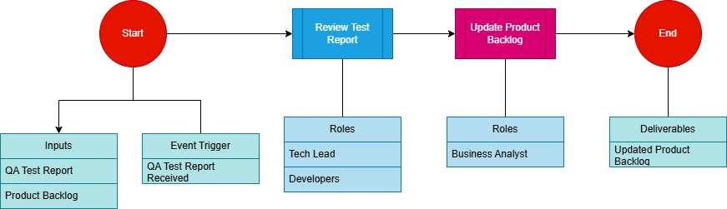
Process Actions:
Action | Responsible  Role | Accountable  Role | Consulted  Role | Informed  Role
Review QA Test Report | Tech Lead  Developers | Tech Lead  Developers | Business Analyst  (Product Owner) | Solution Architect
Update Product Backlog | Business Analyst  (Product Owner) | Business Analyst  (Product Owner) | Tech Lead  Developers | Solution Architect
Bug Fixing Phase Deliverables:
Artefact | Roles Responsible | Delivery Duration
Updated Product Backlog | Business Analyst  (Product Owner) | End of QA Test Report Review
Conclusion
This document provides a structured and disciplined development framework aligned with CMMI best practices and Agile delivery principles. By defining clear processes, responsibilities, triggers, and deliverables, the organization ensures consistent execution across teams and projects. The outlined phases establish transparency, accountability, and quality assurance throughout the software development lifecycle. Ongoing adherence to these processes will enhance predictability, improve stakeholder satisfaction, and support continuous improvement across the development organization.

